# Ineuron Excel Assignment-6



1.What are the various elements of the Excel Interface?Describe how they’re used.

1. Quick Access Toolbar: contains commonly used commands in Excel.
2. Ribbon:Contains the coomands that are available for use in Excel.
3. Name Box:Displays the name of selected cells,range or object.
4. Formula Quick Menu:Provide quick access to commonly-used functions.
5. Formula Bar:Displays the contents of the active cell.
6. Status Bar:Display information about the current state of the Excel.
7. Worksheet View Options:Allows you to change the view of the worksheet.
8. Zoom Slider Control:Allows you to zoom in or out of the worksheet.

2.Write down the various application of excel in the industry.

The most common business uses of ms Excel are business analysis,managing lists of people,operation managemnt and performance reporting.

The software is also handy for office administration,project management and managing programs,contracts and accounts.

3.On the ribbon,make a new tab.Add some different group,insert commands in the groups and name them according to their commands added.copy and paste the screenshot of the steps you followed.

Open the Excel option dialog box(by right-clicking on any of the existing tabs and then clicking on ‘customise the ribbon’.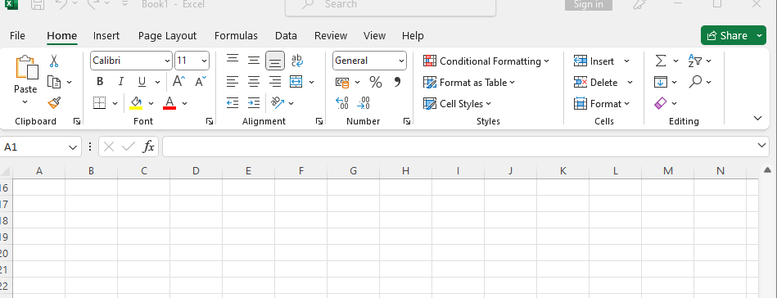

Customize the ribbon will display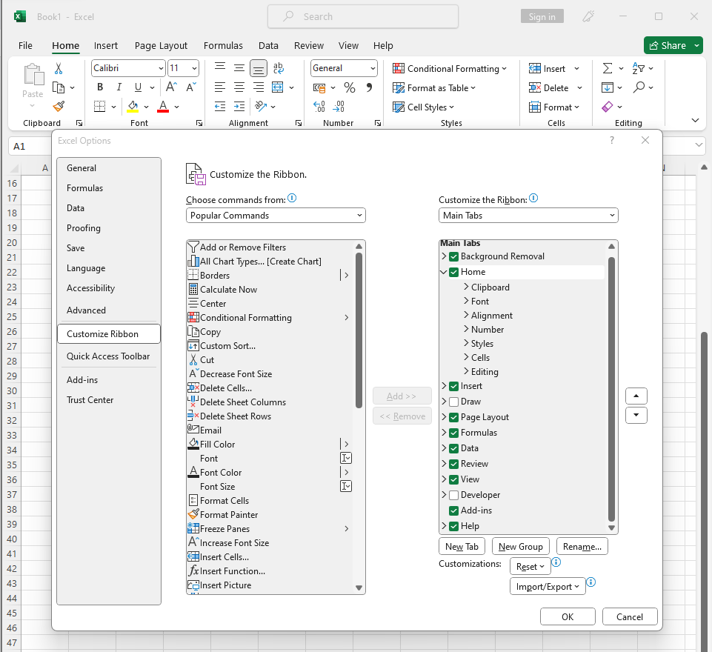

Change the name by clicking on rename 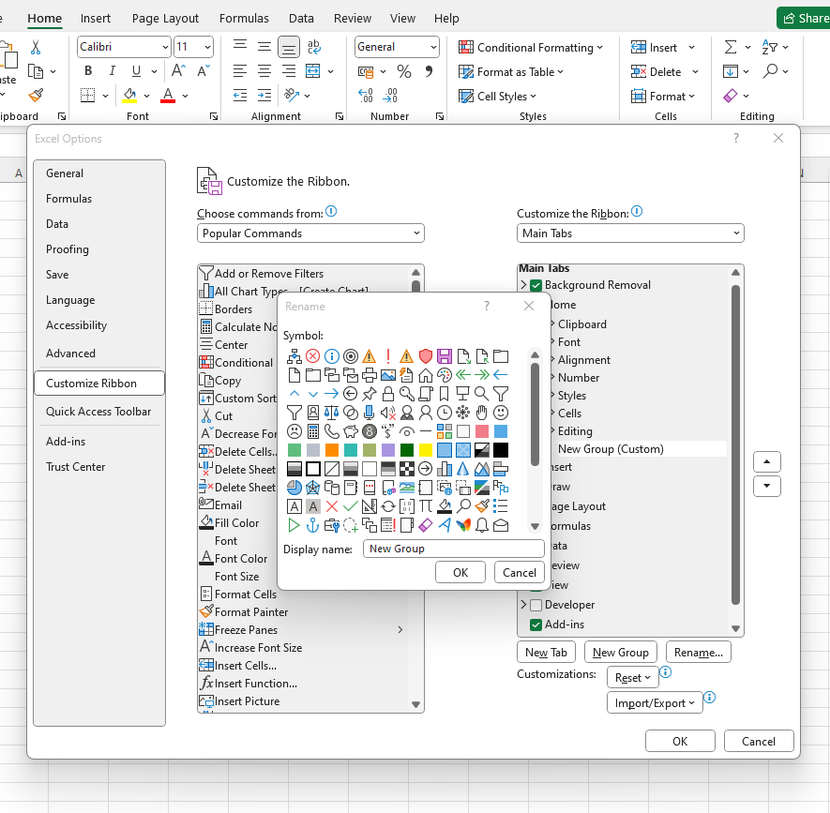

Enter the name you want to assign to the selected tab.

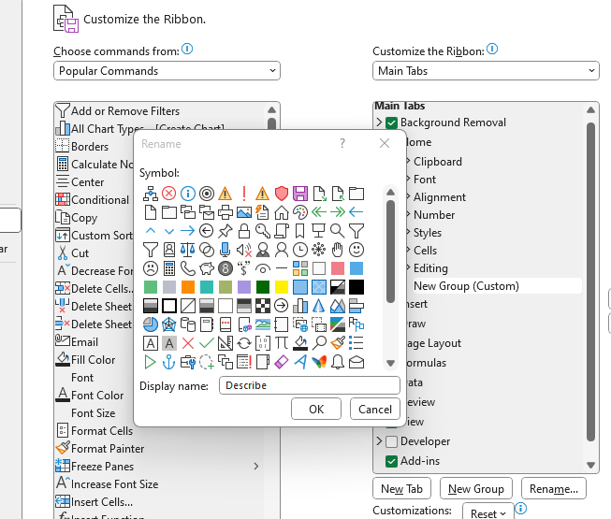

Then the new group is created in a name ‘Describe ‘.

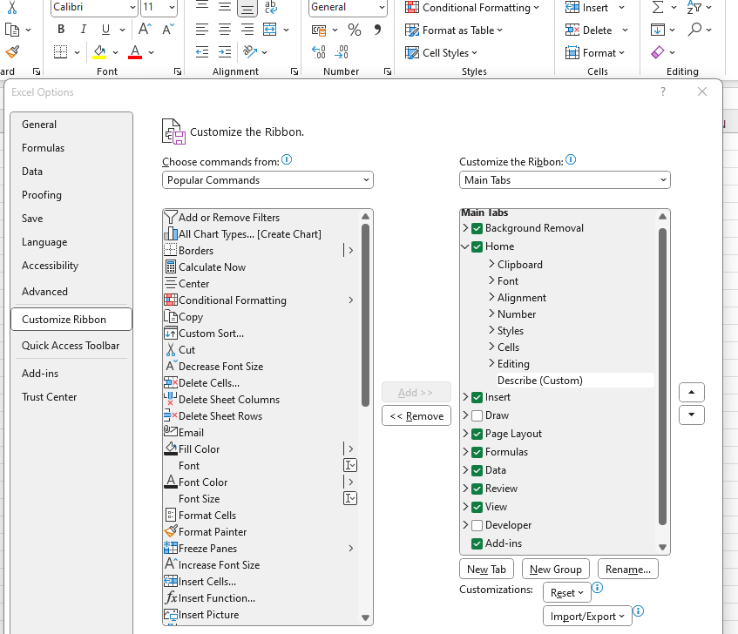

Add a Macros under ‘Describe’tab.

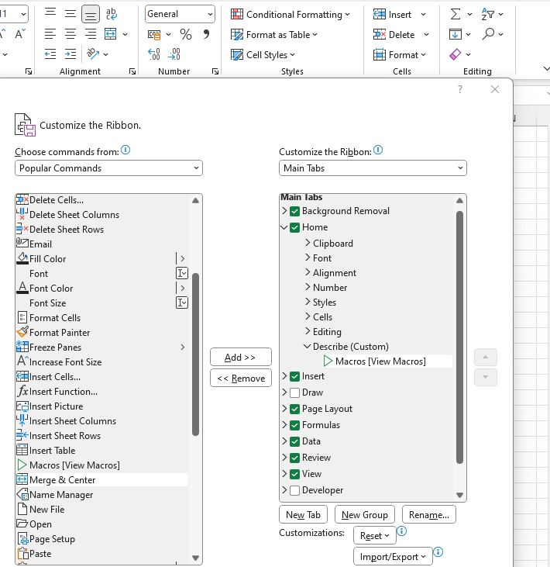

Click ok.

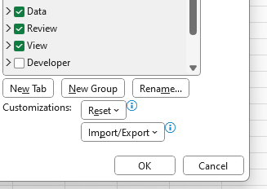

New tab is created.

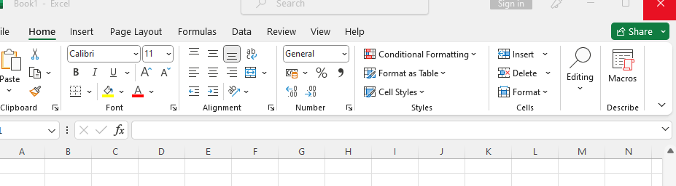

4.Make a list of different shortcut keys that are only connected to formatting with their functions.

|  |  |
| --- | --- |
| Short cut keys | Descriptions |
| Ctrl+X | Cut the selected content to the clipboard. |
| Ctrl+C | Copy the selected content to the clipboard. |
| Ctrl+V | Paste the content of the clipboard. |
| Ctrl+A | Select all document content. |
| Ctrl+B | Apply bold formatting to text. |
| Ctrl+i | Apply italic formatting to text. |
| Ctrl+U | Apply underline formatting to text. |

5.What distinguishes Excel from other analytical tools?

* It’s esay to get started with Excel.
* The learning resources are very rich.
* You can do lot of things with excel:Modeling,visualisation,reports,dynamic charts.
* It can help you understand the meaning of many operations before further learning other tools

6.Create a table and add a custom header and footer to you table.

